

**Heart’s Delight!**

**Circle Dance Workshop**

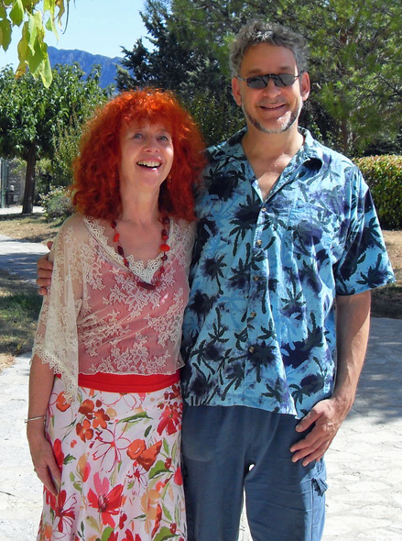

By popular demand Bethan & Stefan Freedman, two of Europe’s most popular and colorful circle dance teachers, are returning to Knoxville. We will be enveloped by dances that delight the heart, at times passionate, playful or deeply restorative.

Dances will include exquisite original choreographies, as well as traditional steps and styles. Dancers of all levels of experience are warmly welcome.

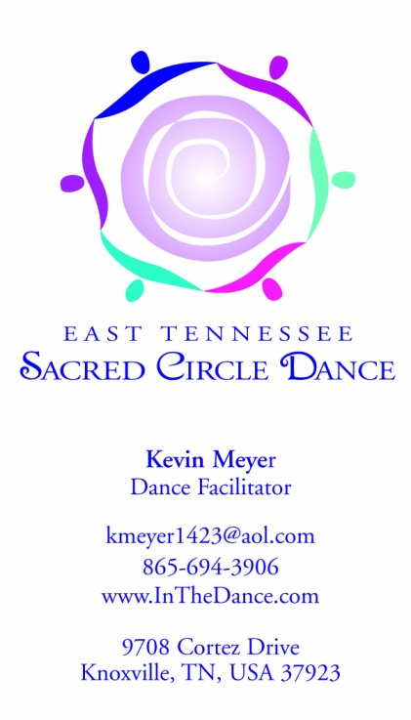

**October 21 - 22**

Knoxville Square Dance Center,

828 Tulip Ave, Knoxville, TN

Cost: $125 Sat + Sun, $75 Sat only

Details at [www.InTheDance.com](http://www.InTheDance.com) or call Kevin at (865) 406-6452